- It looks increasingly likely that Keir Starmer will be forced to stand down as UK Prime Minister. But the identity of his successor remains uncertain. If the contest is delayed to allow Andy Burnham to take part, we expect there will be a persistent uncertainty premium on UK gilts, with the 10-year yield staying above 5%.
- Quarterly GDP growth of 0.6% in Q1 likely overstates the underlying strength of the economy. The ONS has admitted evidence of what it calls “moving seasonality” and suggests its seasonal adjustment process will gradually catch up. Until it does, we’ll build a seasonal pattern into our GDP forecast. With the softer period coinciding with the peak impact of the Middle East conflict, GDP is likely to fall in the middle of this year.
The fallout from Labour’s poor local election performance has continued this week. As yet, no-one has secured the signatures of the 81 Labour MPs needed to trigger a leadership contest. But almost 100 of Labour’s 405 MPs have called on Prime Minister Keir Starmer to stand down, and a leadership contest looks almost certain.
Starmer has said he will take part in any leadership contest. Wes Streeting resigned as Health Secretary and is thought to want to stand, but it’s uncertain he has enough support among MPs. Andy Burnham has announced he wants to quit as Mayor of Greater Manchester to stand in a by-election in Makerfield. If he won that by-election, he would become an MP again and so would be eligible to participate in a leadership contest.
Polling by Survation suggests Burnham would easily win a vote of Labour members (Chart 1). He also has the strongest favourability rating of any senior UK politician, according to YouGov.
Chart 1: Andy Burnham would be favourite to be the next Labour leader, if he can get on the ballot paper
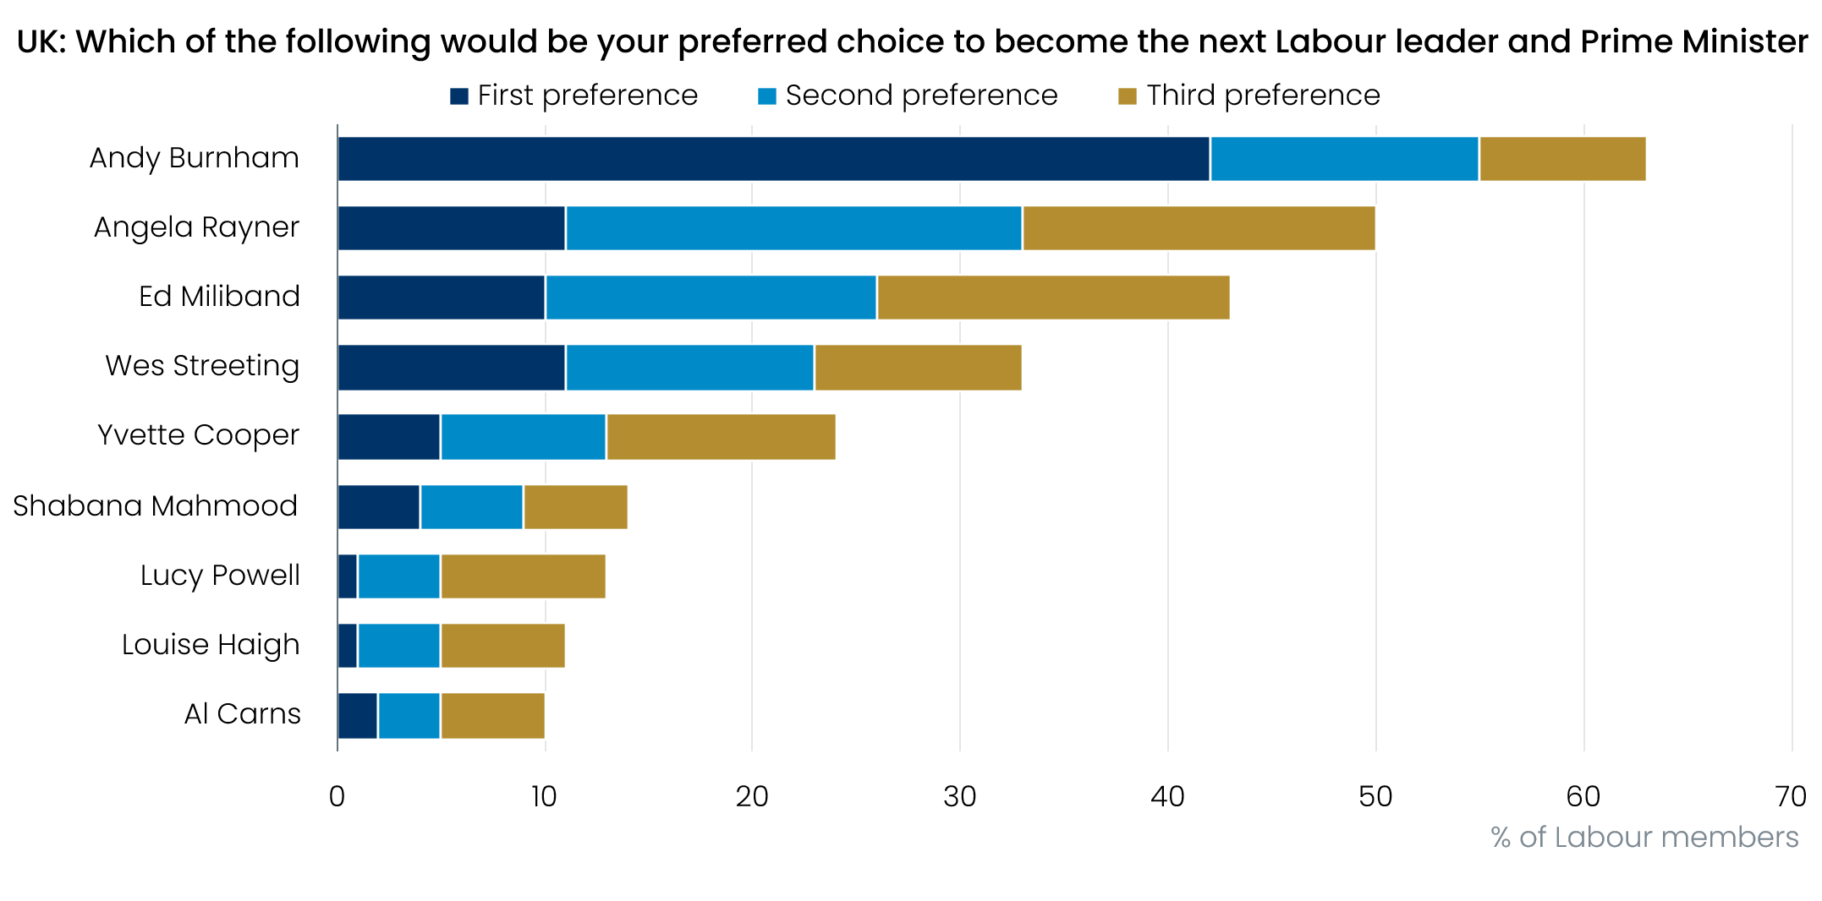
Source: Survation

Burnham will need permission from Labour’s national executive committee to stand. The NEC blocked him from standing in another by-election in February, but it seems unlikely to stand in his way this time. However, even if Burnham can stand, victory is far from certain – Reform UK won all of the wards located in the Makerfield constituency in last week’s local council elections.
If the party is prepared to wait for Burnham, this suggests it will be several months until the leadership contest takes place. This points to a persistent uncertainty premium on UK gilts, and as we argued in a note published this week, the 10-year yield is likely to remain above 5% this year.
Turning to economic data, this week’s only major release was the GDP data for March, which completed the picture for Q1. GDP rose by 0.3% m/m in March, and though the two previous months were both revised down, this left output up 0.6% q/q in Q1. The first cut of the expenditure data reported stronger outturns across the board, with consumer spending (+0.6% q/q) and business investment (+0.7% q/q) standing out.
The apparent Q1 strength mirrors the picture seen in most years since the pandemic (Chart 2). In other years, momentum has quickly ebbed away, and we’ve argued that this is evidence of residual seasonality in the data.
Chart 2: The strong Q1 was consistent with the experience of the post-pandemic period
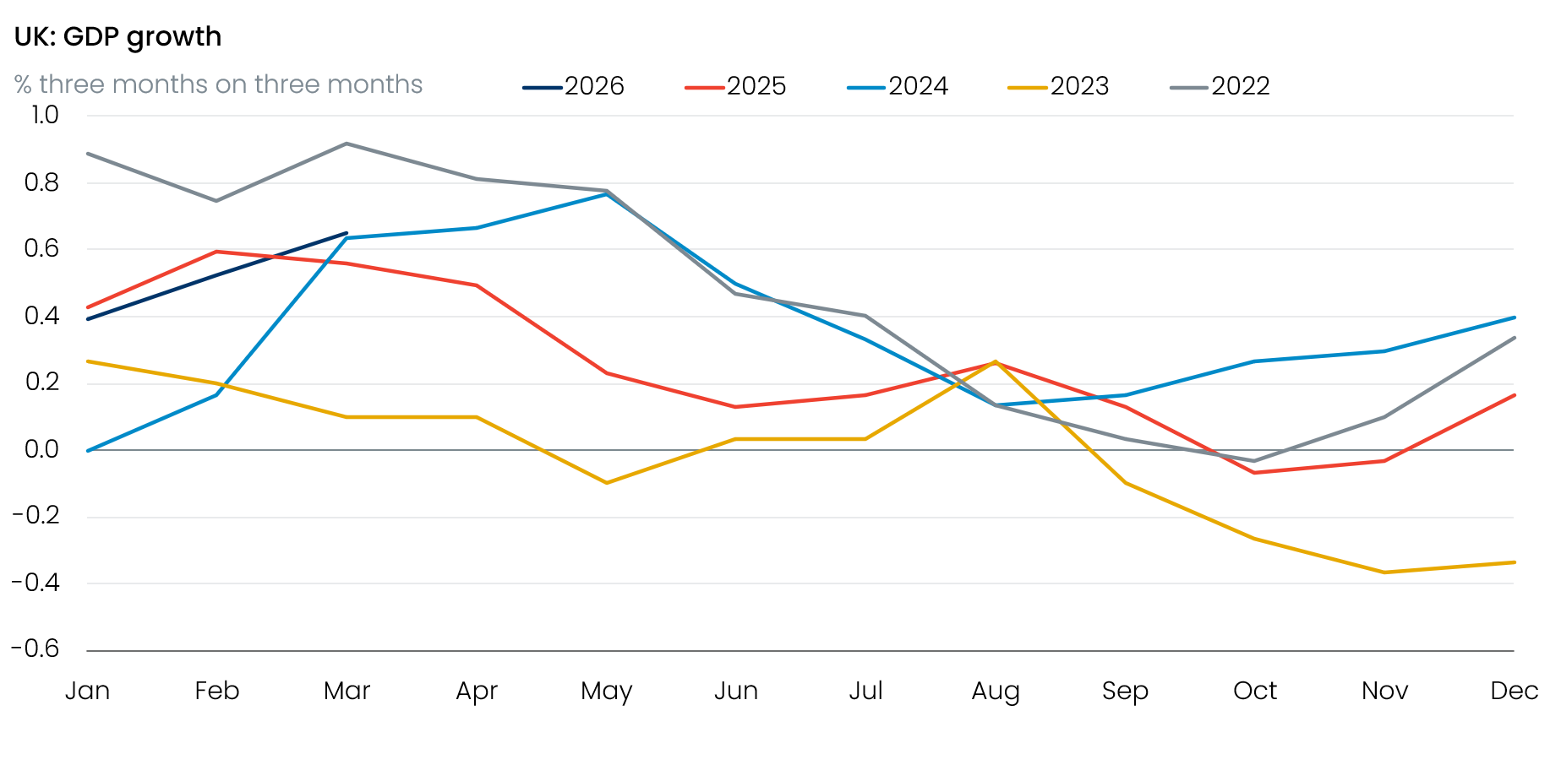
Source: Haver Analytics
The Office for National Statistics published an article and blog on this issue this week. The upshot is that it largely agrees with our analysis that there has been a structural shift in the seasonal pattern of spending towards Q1, a phenomenon that the ONS prefers to label as “moving seasonality” rather than residual seasonality.
Regardless of the label applied, it means that the GDP series will likely continue to have a seasonal pattern until the ONS’s seasonal adjustment process – which requires 3-5 years’ worth of data – catches up. Incorporating the data for the latest quarter into this process meant that the ONS shaved 0.1ppt off the Q1 growth rates for 2024 and 2025. As new data becomes available over the next few years and the ONS continues to re-estimate its seasonal factors, we expect the quarterly profile for the post-pandemic period will become more balanced.
Until that happens, we will build a seasonal profile into our near-term GDP forecasts. Given that the annual loss of momentum will coincide with the peak impact of the Iran conflict, we think there’s a good chance that GDP will fall in the middle of this year.

The week ahead
A busy week of releases kicks off with Tuesday’s labour market data. Pay growth has been gradually losing momentum over recent months, and we expect this to have continued in the three months to March, with headline total earnings growth set to come in at 3.7%, and regular pay growth a little softer at 3.5%.
Labour Force Survey data remains beset by volatility, and a very low single-month estimate for unemployment in February dragged down the three-month average for that month. Given that figure will remain part of the calculation for the January to March period, we think unemployment will come in around 5%, but this probably understates the true level of joblessness.
The April inflation outturn will play an outsized role in the outlook for 2026 as a whole, as it will include the once-a-year change in regulated and inflation-linked prices. These categories account for around 14% of core inflation. We know the increase in water bills will be a lot smaller than a year ago, while the government has frozen rail fares. Pure inflation-linked increases should be higher, given that inflation was higher in 2025 than in 2024, but overall, we expect the annual price rises to be smaller than a year ago.
Elsewhere, there will be downward pressure from the energy category, with Ofgem’s price cap having fallen by 7% on April 1, after the Chancellor removed some green levies. However, this impact will be more than offset by a large increase in fuel prices. Weekly data from the Department for Energy and Climate Change suggests that petrol prices rose by 15% between March and April, having fallen by 2.1% between those months last year. This factor alone will add 0.5ppts to inflation. We expect CPI inflation to come in at 3.3% in April, unchanged from March’s reading.
Retail sales rose strongly in March, but this outturn was heavily reliant on the strength of fuel sales, with the ONS reporting anecdotal evidence that many motorists filled up their tanks before they were empty to try to beat price rises. This effect is likely to have reversed in April. We also expect some payback from March’s chunky rises in non-food and non-store sales, along with a recovery in food sales. Overall, we forecast a 0.5% m/m fall in sales, though given the recent volatility in the sub-categories there’s even more scope for an unexpected result than normal.

Table 1: Week ahead calendar
Date | Events | Period | Measure | Unit | Previous | Forecast
May 19 | LFS unemployment | Jan-Mar | Rate | % | 4.9 | 5.0
May 19 | Average earnings (total pay) | Mar | 3m, y/y | % | 3.8 | 3.7
May 19 | Average earnings (regular pay) | Mar | 3m, y/y | % | 3.6 | 3.5
May 20 | CPI inflation | Apr | m/m | % | 0.7 | 1.3
May 20 | CPI inflation | Apr | y/y | % | 3.3 | 3.3
May 20 | RPI inflation | Apr | m/m | % | 0.8 | 1.7
May 20 | RPI inflation | Apr | y/y | % | 4.1 | 4.1
May 20 | Producer input prices | Apr | m/m | % | 4.4 | 1.0
May 20 | Producer input prices | Apr | y/y | % | 5.4 | 6.3
May 20 | Producer output prices | Apr | m/m | % | 0.9 | 0.7
May 20 | Producer output prices | Apr | y/y | % | 2.6 | 2.8
May 20 | Land Registry house prices | Mar | y/y | % | 1.2 | -0.1
May 21 | S&P Global manufacturing | May | PMI | % bal | 53.7 | 53.0
May 21 | S&P Global services | May | PMI | % bal | 52.7 | 52.5
May 21 | S&P Global composite | May | PMI | % bal | 52.6 | 52.4
May 22 | GfK consumer confidence | May | Headline | % bal | -25 | -27
May 22 | Public finances | Apr | PSNB | £bn | 12.6 | 17.0
May 22 | Retail sales inc fuel | Apr | m/m | % | 0.7 | -0.5
May 22 | Retail sales inc fuel | Apr | y/y | % | 1.7 | 1.3
Source: Oxford Economics

Key forecasts
Table 2: UK forecast overview
(ANNUAL PERCENTAGE CHANGES UNLESS SPECIFIED)
 | 2023 | 2024 | 2025 | 2026 | 2027 | 2028
GDP | 0.3 | 1.1 | 1.4 | 0.6 | 0.8 | 1.7
Private consumption | -0.3 | -0.1 | 0.8 | 0.4 | 0.4 | 1.4
Fixed investment | 0.5 | 1.8 | 4.3 | 0.2 | 1.4 | 2.6
Government consumption | 2.1 | 2.9 | 1.7 | 1.9 | 1.6 | 1.4
Consumer prices | 7.3 | 2.5 | 3.4 | 4.0 | 2.9 | 1.9
Unemployment rate (%) | 4.1 | 4.3 | 4.9 | 5.3 | 5.5 | 5.0
Current a/c balance (% of GDP) | -3.6 | -3.0 | -2.4 | -3.2 | -3.1 | -2.5
Government balance (% of GDP) | 5.2 | 5.2 | 5.0 | 4.0 | 3.7 | 2.9
Central bank policy rate (%, EOP) | 5.25 | 4.75 | 3.75 | 3.75 | 3.50 | 3.00
10yr govt. bond yield (%, EOP) | 3.54 | 4.57 | 4.47 | 4.84 | 4.28 | 3.85
Exchange rate (US$ per £, EOP) | 1.27 | 1.25 | 1.35 | 1.30 | 1.30 | 1.30
Exchange rate (euro per £, EOP) | 1.15 | 1.21 | 1.15 | 1.12 | 1.10 | 1.10
Source: Oxford Economics
Table 3: Quarterly forecasts for the UK
 | 2026 |  |  |  | 2027
 | Q1 | Q2 | Q3 | Q4 | Q1 | Q2 | Q3 | Q4
GDP (% year) | 0.9 | 0.7 | 0.5 | 0.5 | 0.2 | 0.6 | 1.0 | 1.3
CPI inflation (% year) | 3.1 | 3.7 | 4.4 | 4.6 | 4.3 | 3.0 | 2.3 | 2.0
Bank Rate (%, EOP) | 3.75 | 3.75 | 3.75 | 3.75 | 3.75 | 3.75 | 3.75 | 3.50
10yr gilt yield (%, EOP) | 4.88 | 5.10 | 5.14 | 5.13 | 5.09 | 4.96 | 4.78 | 4.57
US$ per £ (EOP) | 1.32 | 1.34 | 1.32 | 1.30 | 1.30 | 1.30 | 1.30 | 1.30
Euro per £ (EOP) | 1.14 | 1.16 | 1.14 | 1.12 | 1.11 | 1.10 | 1.10 | 1.10
Source: Oxford Economics

Latest Country Economic Forecast:
April 20, 2026

Recent publications

Data Insights
Robust Q1 overstates economy’s strength
Pickup in the PMI won’t last
Mortgage activity strengthened in March, despite higher interest rates
Manufacturing PMI rise masks weakness
March retail bounce too good to be true

Research Briefings
Why 5% 10-year gilt yields are here to stay
MPC maintains a watching brief, but chances of higher rates are rising
Residual seasonality issues continue to flatter activity growth in Q1
MPC preview – Maintaining the ‘wait and see’ message
What different migration profiles mean for the economy and public finances

Contacts

Oxford Economics' UK team
- Andrew Goodwin – Chief UK Economist – agoodwin@oxfordeconomics.com
- Edward Allenby - Senior UK Economist - eallenby@oxfordeconomics.com

